**E-Fixed Deposit for The Grill House Restaurant**

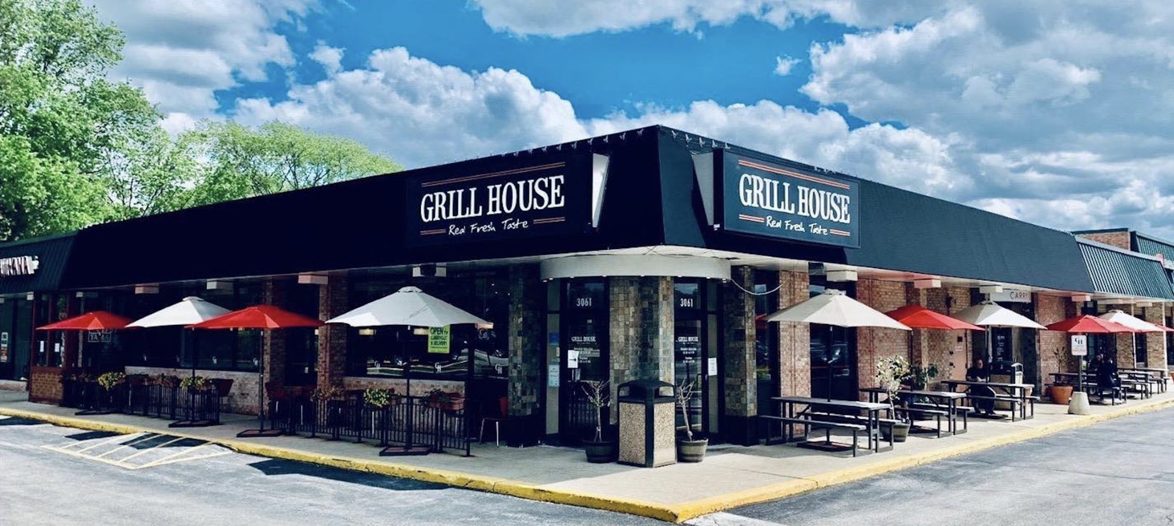

**Submitted by:**

Mohit Pal

Table of Contents

1- Introduction 3

Business Analysis Core Concept Model (BACCM) 3

2- Identify stakeholders 4

3- The proposed system workflow 5

As-Is Process map: 5

Future Process map: 5

4- Finding the Scope of E-Fixed Deposit (Context Diagram) 6

Main features of E-FIXED DEPOSIT 6

5- The In-scope and Out of Scope Items for E-FIXED DEPOSIT 7

9- Key functional and Non-functional requirements 7

6- Wireframe for Update menu page and table booking 8

Update Menu Page 8

Table Booking Page 9

7-User stories and Acceptance criteria 9

8-Sales Analysis by Region on Tableau 10

9- Excel Work 11

9.1-Sales report of Madison, Ney York and San Jose 11

9.1.2.1-Ascending order of sales by city 11

9.1.2.2-Decending order by sales of city 12

9.2-Find Sales 12

9.2.1- Restaurant ID 1200789, find the sales for the month of June 12

9.2.2- Restaurant ID 1200739, find the sales for the month of April 12

9.3.3- Restaurant ID 1200352, find the sales for the month of January 12

# 1- Introduction

One of the leading banks across the globe, is ABC Bank. It has a presence in 56 countries in the world.

ABC Bank currently has a manual option to create fixed deposits. The bank users go to the nearest ABC Bank branch and create a fixed deposit. ABC Bank has a future vision of being a 100% online bank and wants to do away with all its manual banking processes. They have identified the need to create e-fixed deposits.

ABC Bank currently wants to introduce this to their existing bank users with a future plan of introducing this feature to non-ABC Bank users.

Advantages of opening an FD online

* **Easy and less time-consuming**: An online FD can eliminate the process of visiting the bank physically and makes the process of creating an FD an extremely easy and hassle-free process.
* **Easy payment:**Paying for the FD is extremely easy and can be done directly through net banking that makes the process of payment very convenient. All that is required is to transfer the money from the savings account to the respective FD account.
* **Easy renewal and closure:** Once an FD account is opened online, it is possible to renew and close the deposit online instantly. Therefore, it eliminates the need of going to the bank for any of these purposes.

## Business Analysis Core Concept Model (BACCM)

# 2- Identify stakeholders

RACI matrix is used here for identifying the responsibility of each stakeholder involved in the process:

Responsible (R): The individuals who will be performing the work on the task.

Accountable (A): The individual who is ultimately answerable for the completion of the task and is the decision maker.

Consulted (C): The stakeholder (group) who will be asked to provide opinion or information about the task.

Informed (I): The stakeholder (group) that is kept up to date on the task and its outcome.

|  |  |  |  |  |
| --- | --- | --- | --- | --- |
| **Stakeholders** | **Responsible** | **Accountable** | **Consulted** | **Informed** |
| Project Manager |  | A |  |  |
| Developer | R |  |  |  |
| Tester | R |  |  |  |
| Domain SME |  |  | C |  |
| Operational Support |  |  | C |  |
| Implementation SME | R |  |  |  |
| Business Analyst | R | A |  |  |
| Manager |  |  | C | I |
| Customers |  |  |  | I |
| CEO |  |  |  | I |
| Waiter |  |  | C |  |

# 3- The proposed system workflow

## As-Is Process map:

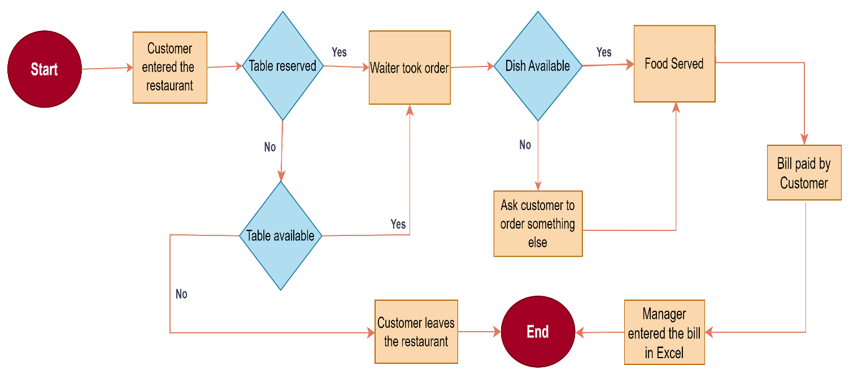

## Future Process map:

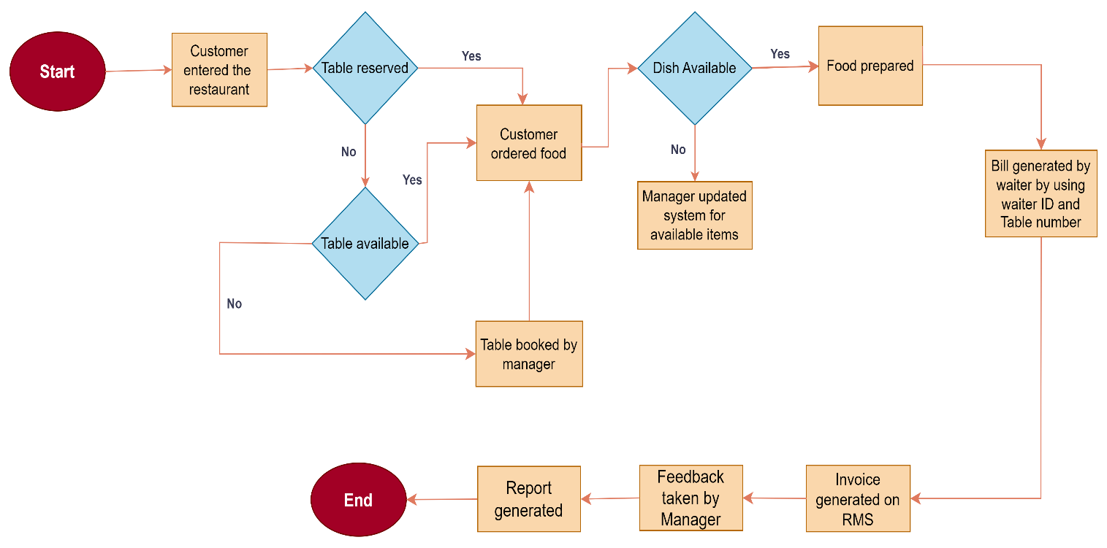

# 4- Finding the Scope of E-Fixed Deposit (E-FIXED DEPOSIT) (Context Diagram)

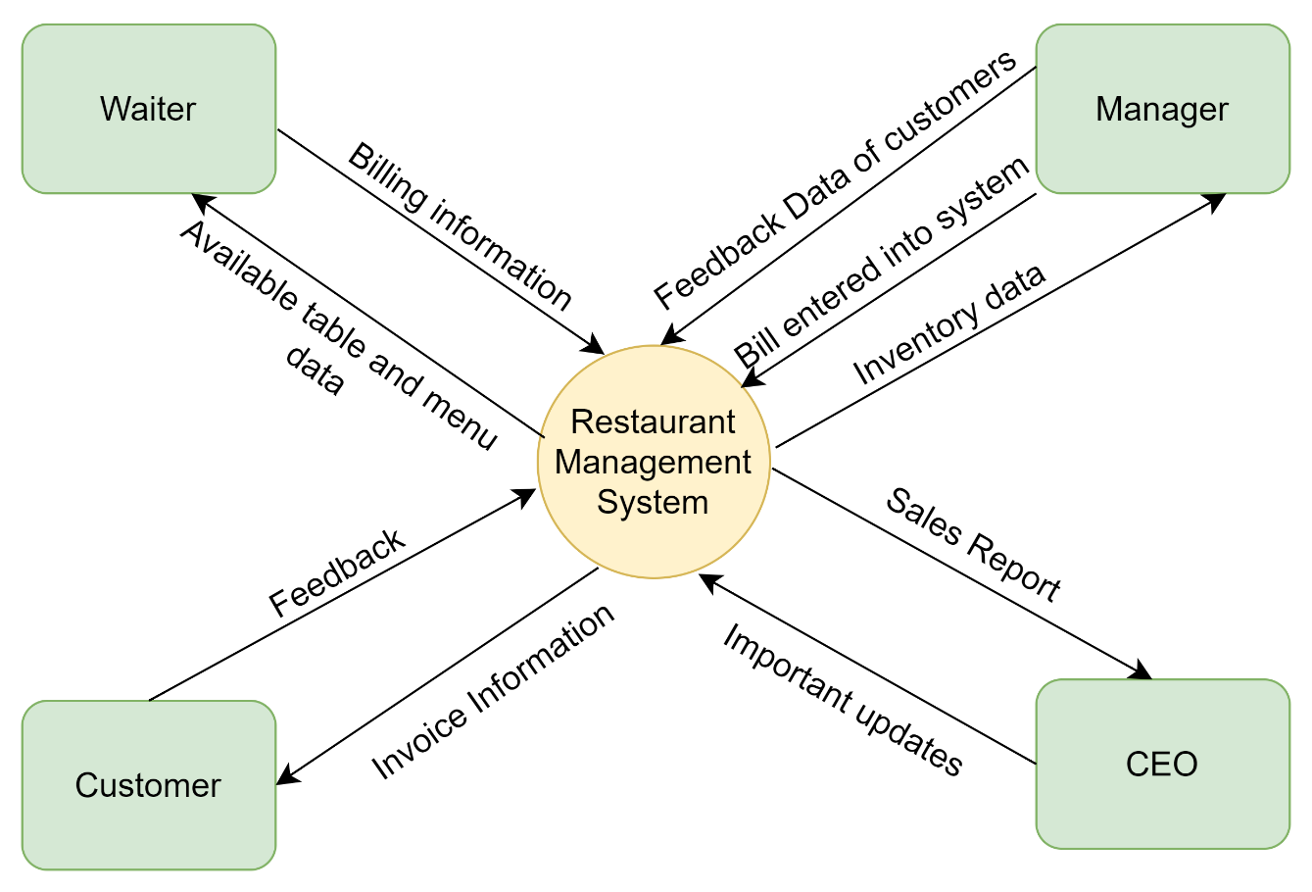

## Main features of E-FIXED DEPOSIT

1. Web-based Management System

* Must have MYSQL database and operate with Windows 2016
* Must have 3 login portals
* Must respond within 1 second
* Must be interactive and user-friendly
* Must be working all the times

1. Waiter and manager Registration and Login
2. Schedule/ Reschedule/ cancel table booking
3. Store customer's feedback records for anytime access
4. Waiter ID and Table number generation
5. Vacant and allocated table information
6. Bill generation
7. Customer’s Invoice generation
8. Reports for CEO

* Total sales of the day by dine in customers
* Total sales of the day by home delivery customers
* Total sales of the day (home delivery and dine in customers consolidated)
* Name the top 10 most sold dishes for the day
* Total sales every weekend (to be done by inputting the dates)
* Total sales every month (to be done by inputting the dates)
* List of dishes not sold in the current month (this is to phase out dishes that customers are not ordering)
* Total sales across all cities
* Total sales for each city

# 5- The In-scope and Out of Scope Items for E-FIXED DEPOSIT

|  |  |
| --- | --- |
| **In-Scope Requirements** | **Out-of-Scope Requirements** |
| Table booking on E-FIXED DEPOSIT | Booked only by waiters |
| Manager Registration | Only Managers can register |
| Waiters Registration | Only waiters can register |
| Add / Update menu records | Must be done by managers only |
| Online invoice generation | Generated by waiters only |
| Feedback given by customers must be recorded | Only managers can record feedback |
| Search button to search dishes | Only given to waiters and managers |
| Restaurant staff management | Only The Grill House restaurant staff management |
| Billing and Reports generation | Billing must be generated at the end |

# 9- Key functional and Non-functional requirements

1. **Functional Requirements:**

* Waiters and Managers registration screen
* Log- in screen for waiters, managers and CEO
* Table booking and allocation
* Customer’s feedback records
* Waiter’s menu page
* Manager’s menu update/delete page
* Table occupancy details portal for managers
* Staff allocation and management
* Billing information page
* Sales reports for CEO
* Payment gateway page

1. **Non-functional Requirements:**

* MySQL Databaseto be used since it is open source and free.
* Creating and maintaining the program in Java
* The operating systemshall be Windows 2016
* The system shall be a web-based application.
* The system shall respond within 1 second
* The system shall keep logs of all the errors
* The system shall be available all the time
* The system should be self-explanatory and very user-friendly.

# 6- Wireframe for Update menu page and table booking

## Update Menu Page

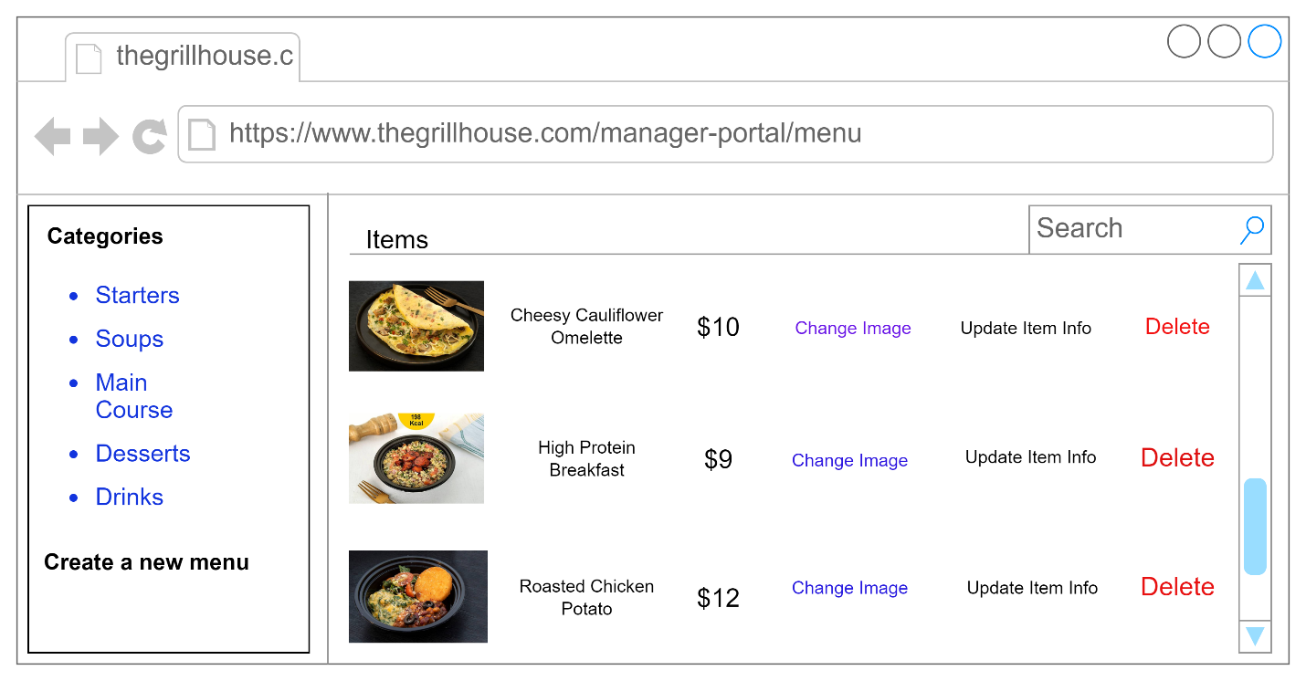

## Table Booking Page

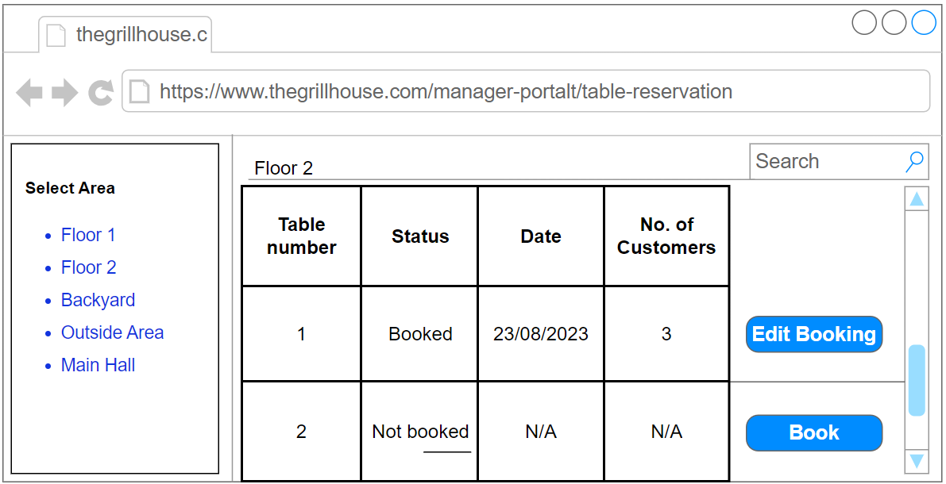

# 7-User stories and Acceptance criteria

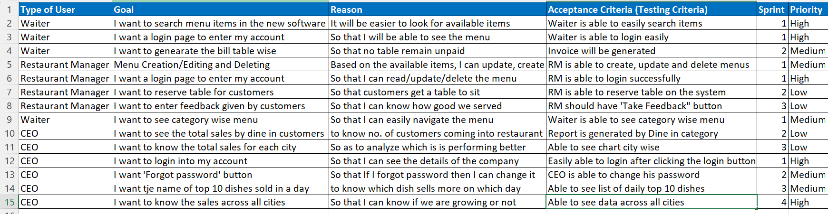

# 8-Sales Analysis by Region on Tableau

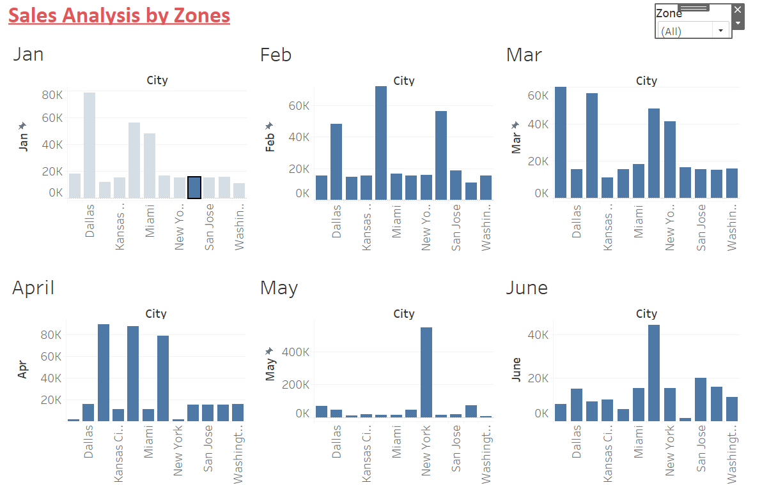

## 8.2 Zone with highest sales

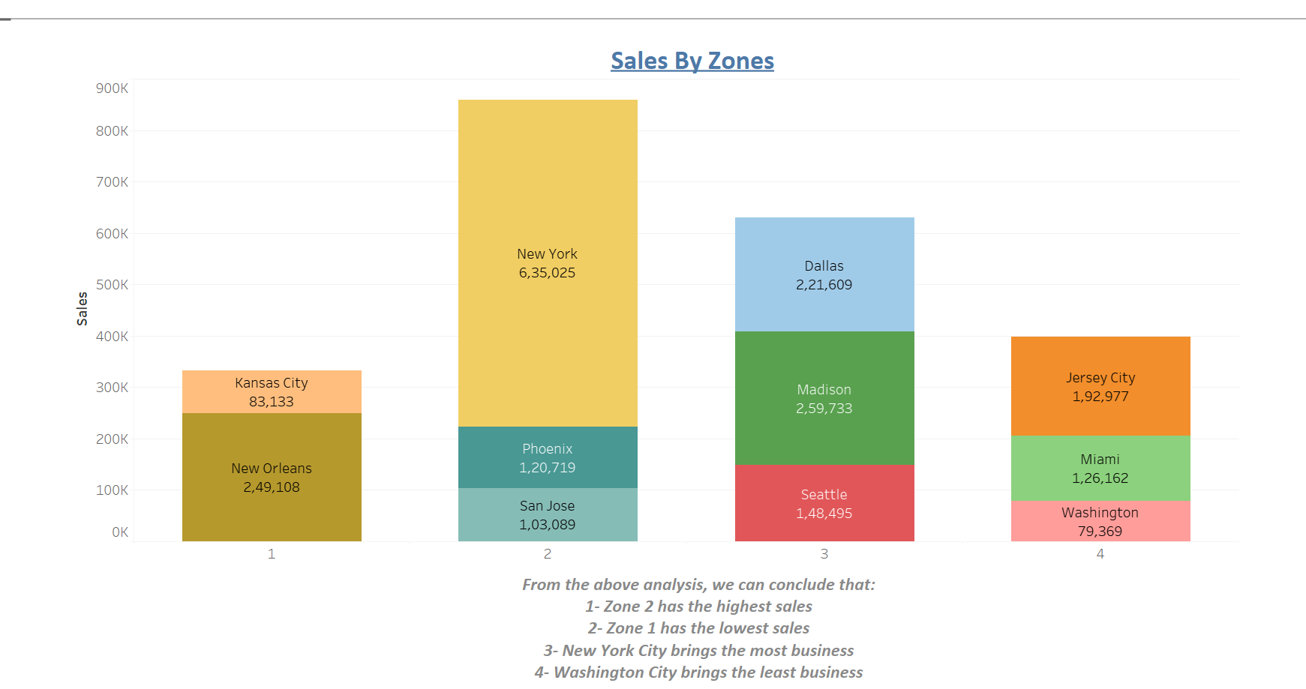

# 

# 9- Excel Work

## 9.1-Sales report of Madison, Ney York and San Jose

## 9.1.2.1-Ascending order of sales by city

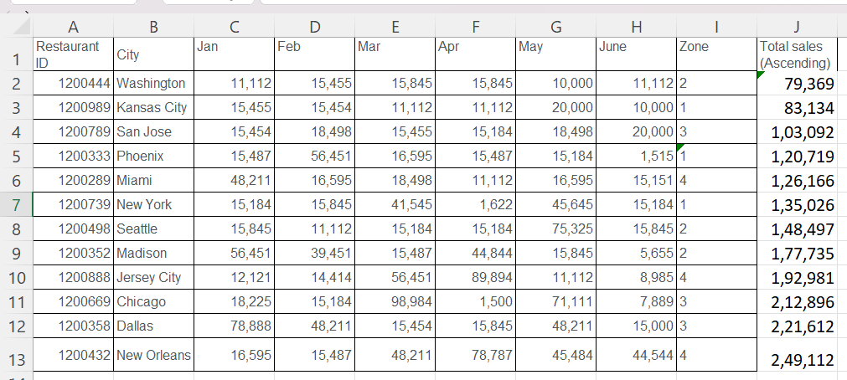

## 9.1.2.2-Decending order by sales of city

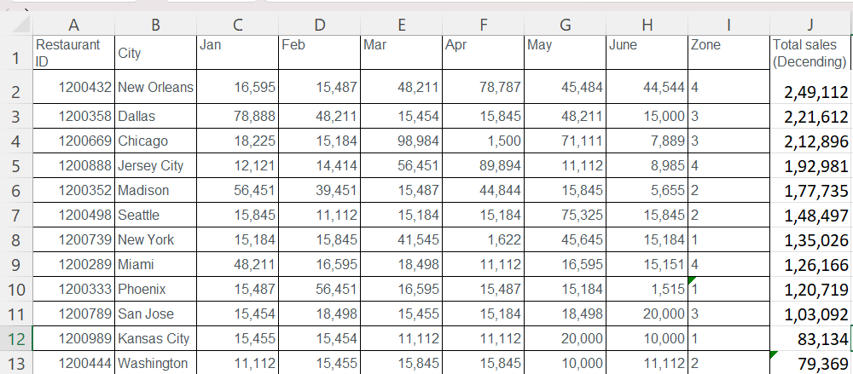

## 9.2-Find Sales

## 9.2.1- Restaurant ID 1200789, find the sales for the month of June

Answer- 20,000

## 9.2.2- Restaurant ID 1200739, find the sales for the month of April

Answer- 1,622

## 9.3.3- Restaurant ID 1200352, find the sales for the month of January

Answer- 56,451